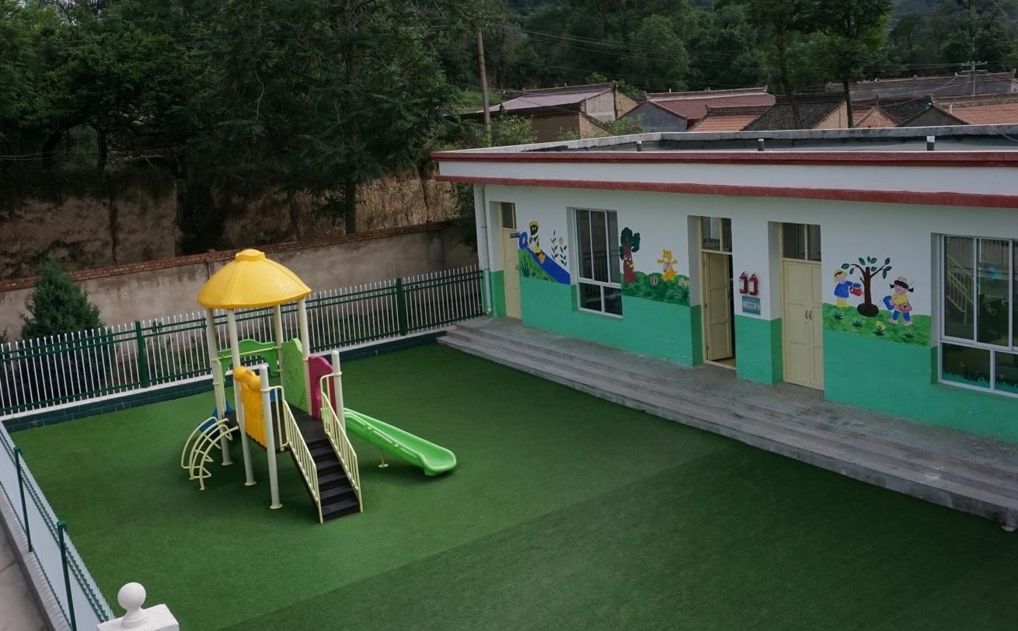

**A Week in 甘肃**

Liang Zhou

What am I doing this summer?

Unclear. It’s most ostensibly a post-college summer trip, and the first real summer vacation I’ve had since middle school. It’s also a reflection on my Chinese heritage, an opportunity to connect with a surprisingly unfamiliar culture. It’s a chance to do all the planning, learning, traveling, almost entirely on my own.

Beyond that, this past week I was given (more accurately, thrown) the opportunity to help out 支教中国2.0 by visiting three of their partner schools in Gansu on their behalf.

These elementary schools all had dedicated computer classrooms, and my role was to evaluate and help them resolve some of their critical IT issues. Given that an MIT computer science degree in no way prepares you for IT difficulties, I was sent with 张老师 (literally, Teacher Zhang), a teacher at 上海培佳双语学校 (literally, Shanghai Peijia Bilingual School) with years of experience maintaining computers for the school. The whole venture became both a chance to volunteer and a one-of-a-kind learning opportunity.

China is divided into 23 provinces (along with a host of other non-provincial areas, such as 上海 Shanghai or 新疆 Xinjiang), and each province is again divided into the equivalent of counties (地区, literally *regions*), which are further divided into areas called 县 (*xian*). Our work was entirely centered within Pingliang (平凉) region, in the Huating (华亭), Zhuanglang (庄浪), and Chongxin (崇信) xian.

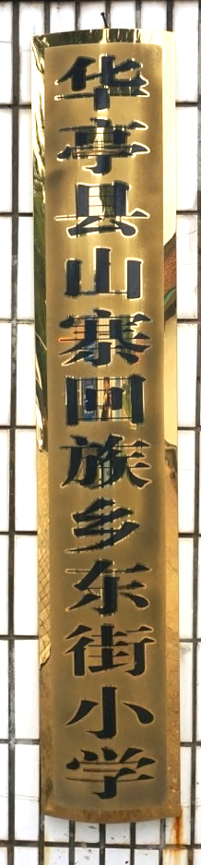  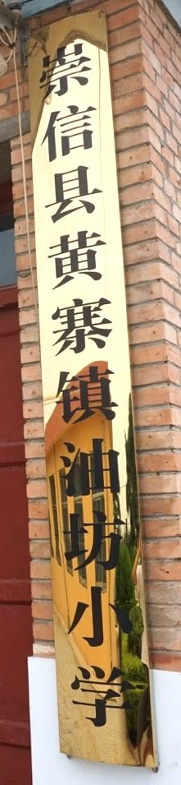

Placards for the schools that we visited!

**7.3 | Tuesday**

It took a whole day to just get from Shanghai to the 平凉 area. I woke up at 5, dragged myself onto the subway, arrived at Shanghai Hongqiao (虹桥) Railway Station, and bought an overpriced breakfast of porridge and a brown rice-youtiao burrito. 张老师 found me, we introduced ourselves, and caught the 7:17 morning train *yawn* for a 7-hour ride to 西安 (Xi’an) at Xi’an North at about 2:30pm. No time to rest: we had to catch a 3:30pm bus from Xi’an bus station, which involved a tight hour’s worth of figuring out the right combination of taking the local metro and walking to the stop. We made it!

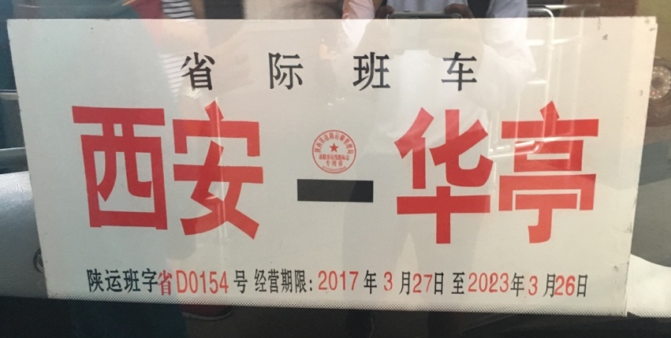

Arrived 5 minutes before it left.

Apparently it was a 7-hour bumpy bus ride…so I’m glad I slept through ~all of it. I woke up groggily to a 10pm arrival in rainy Huating and we quickly found the nearest hotel. Almost all the stores had closed, but we managed to spot a small and remarkably inexpensive dumplings place.

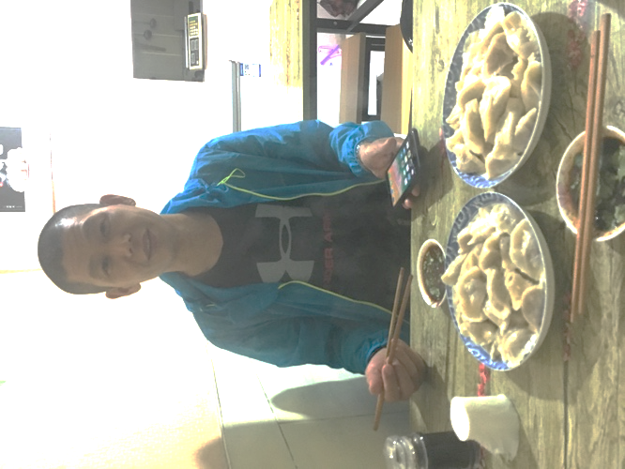

At 11pm. We’re both actually really tired at this point

**7.4 | Wednesday**

Woke up at 6 for the first day of actual work. We met 张老师 (another one, not the one I was traveling with!) from Dongjie elementary school (东街小学), who took us for some morning lamian (拉面). We caught the 7am bus for a 40-minute ride to the village where the school was actually located, met 李 (Li) 校长 (principal), and were introduced to the computer room. We’d just begun to turn them on and assess the situation when the lights went out.

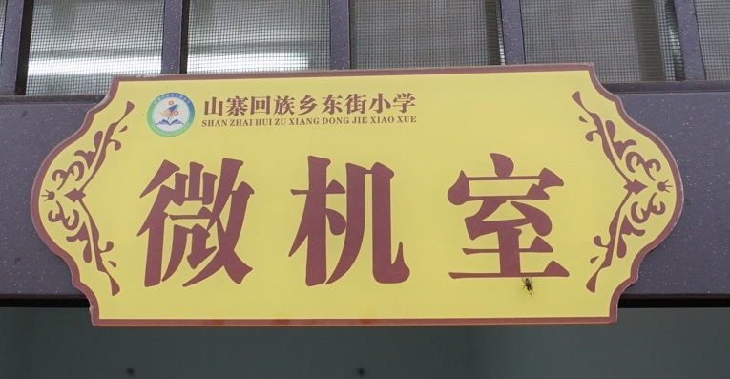

The computer room label

…so, 张老师 came up with the *brilliant idea* to have me teach an English class.

My Chinese is terrible, their pronunciation is off, I have no idea how to be a teacher, etc. We managed to find some common ground near the end learning translations of different animals.



Teaching was stressful but kind of fun. And the kids are cute

The lights came back on, and we set right back to work on the computers. The main reason why their computers were slow was because of a freeware antivirus software called 360, which along with their antivirus software bundled a host of advertisements and other software that slowed the computer to slower than it probably would be even with a virus. Another problem was that students who weren’t proficient at computer usage would arbitrarily click, download, and install from the Internet.

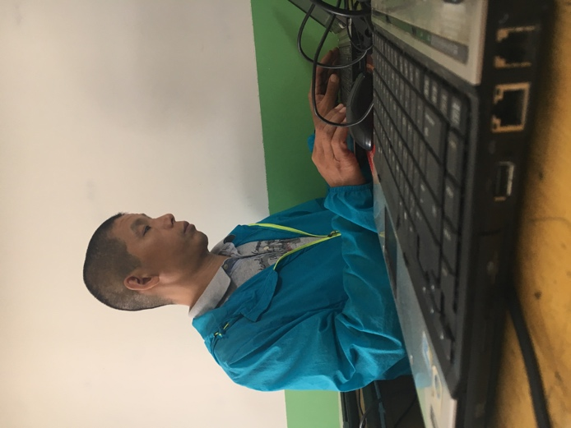

Hard at work. Probably getting rid of 360.

The solution? Reset all the computers to their factory settings, and deal with 360 the best we can by disabling as many extraneous features as possible. Definitely not possible to catch them all, but we finished around 18:00, headed back to Huating on a 面包车 (because they look like loaves of bread), and had some beer.

**7.5 | Thursday**

Woke up early again to take a 2-hour bus to 庄浪. On the bus ride I came up with the simple idea to just give students Limited accounts on their laptops and restricting their ability to easily download and install, and 张老师 decided to install an alternative antivirus software called Huorong (火绒) that wouldn’t be as intrusive as 360. 陈 (Chen) 校长 picked us up and drove us to Liuyao elementary school (刘窑小学). The computers in the long-distance classroom were kept in near-pristine condition, wrapped under towels when not in use.

 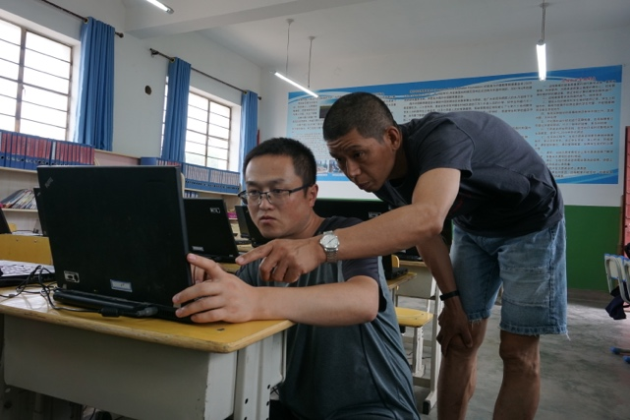

Hard at work fixing and upgrading the laptops in 刘窑小学

On these computers, 360 was still a problem, but another issue was that they didn’t have nearly enough RAM (download more here), so 陈校长 and I upgraded the aging 2G to 8G of RAM, which is a lot, for the non-technical crowd out there.

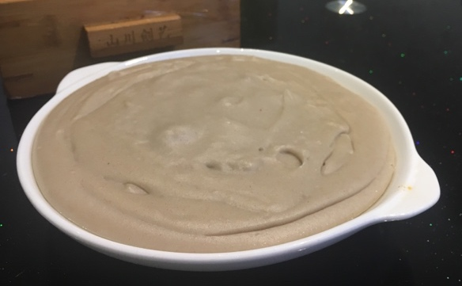

People don’t eat rice here: it’s all noodles. This is pudding made with noodle dough.

**7.6 | Friday**

Finished up the work at 刘窑小学 by late afternoon, and had a delicious dinner of 暖锅 (warm pot?) with 陈校长 and two of the other teachers at 刘窑小学.

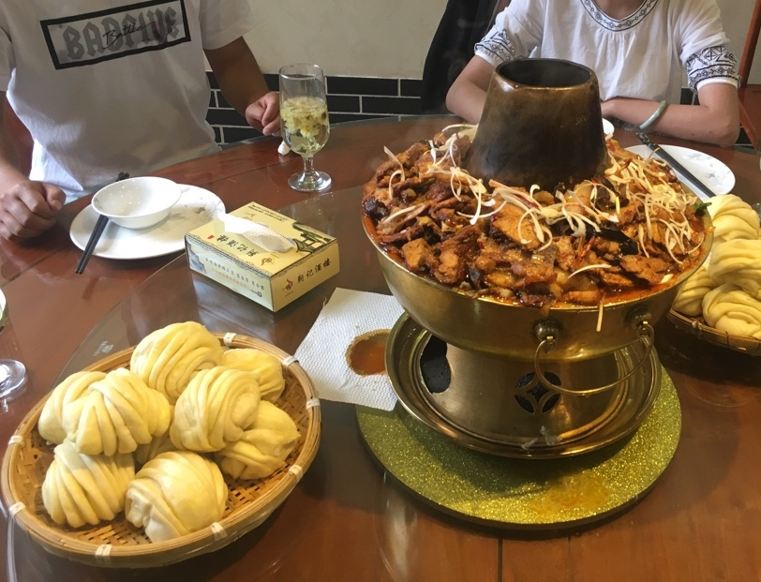

“warm pot”

**7.7 | Saturday**

Woke up at 6:00am to catch a 7:00 bus to 崇信 for 3 hours, and were picked up by 于 (Yu) 校长 and had an early lunch of 肉泡馍 (rou pao mo). 崇信 is located in a river valley (as are all the villages, but the valley-ness was especially prominent with 崇信. 崇信. Youfang elementary school (油坊小学) is located a 15-minute drive away on the northern mountain ridge.

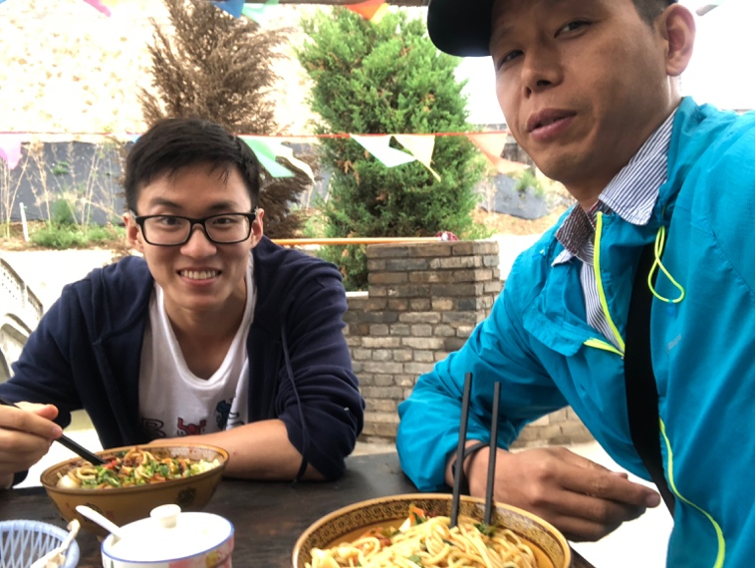

a meal of noodles before climbing 龙泉山

As with 刘窑小学, the teachers here took very good care of their computers. In addition to laptops that needed resetting, there were also desktops with separate BIOS issues. On 于校长’s recommendation, we wrapped up for the day and went on a visit to their local AAAA attraction, Longquan Mountain (龙泉山), which offered absolutely stunning views of the valley below. Just as we reached the peak, it began raining, and 张老师 and I hurried back to a small local hotel.

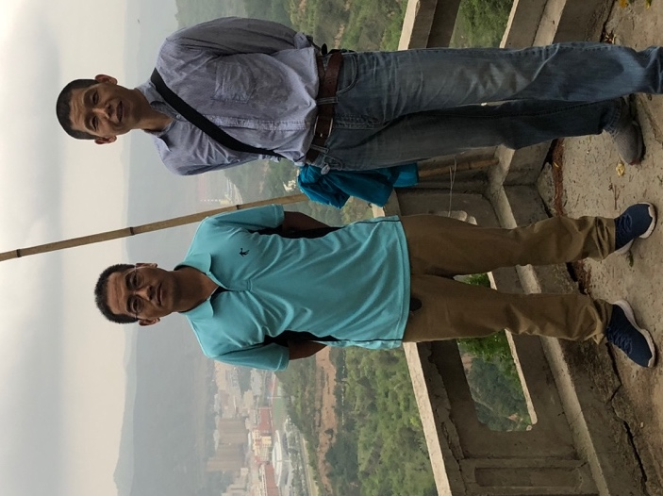 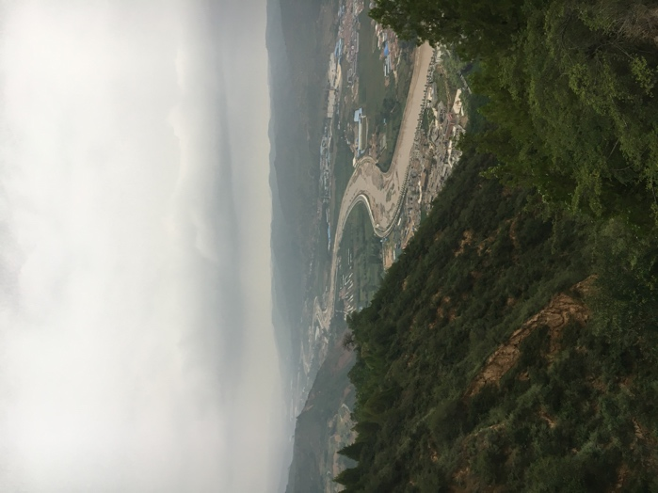

From the top of 龙泉山

**7.8 | Sunday**

Finished up work at 油坊小学 and caught an early 3pm bus back to 西安. No time to eat, but 于校长 bought us snacks for the 5-hour bus ride :)

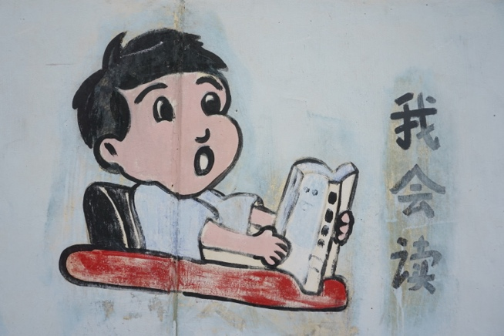 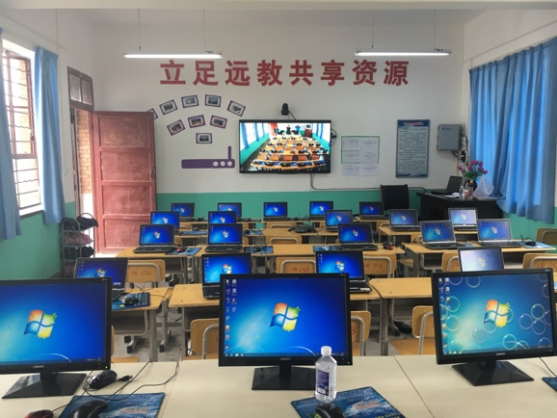

*Left*: I can read. Can you? *Right*: All the computers in 油坊小学 fixed!

**7.9 – 7.10 | Monday – Tuesday**

2-day Xi’an city trip! Brief itinerary (e.g. list of places visited): Xi’an Museum (西安博物院), walked all 8.6 miles (13.7km) of Xi’an city wall (西安城墙), Shaanxi History Museum (陕西历史博物馆), Banpo Museum (半坡博物馆), Muslim Quarter (回民街), Xi’an Great Mosque (清真大寺), Mobike/Ofoing around the city

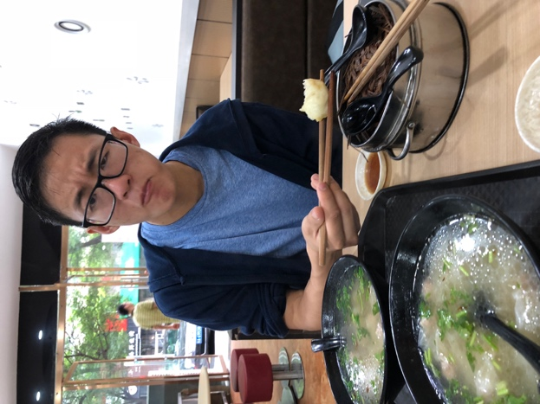 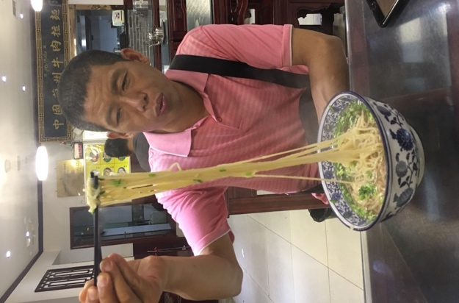

We love food

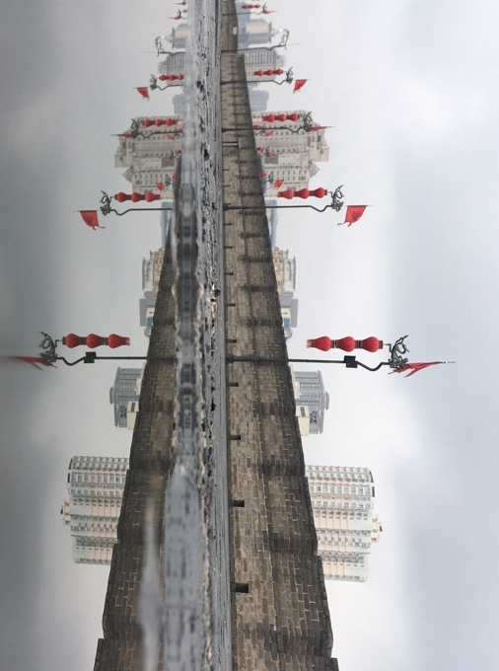

The Xi’an city wall after rain. More rain to come

**7.11 | Wednesday**

Early 9:23 train back to Shanghai. No rain in Shanghai but humidity is off the charts

